**P3 - Discuss the advantages and limitations of animated GIFs** & **M2 – Compare different animation formats**

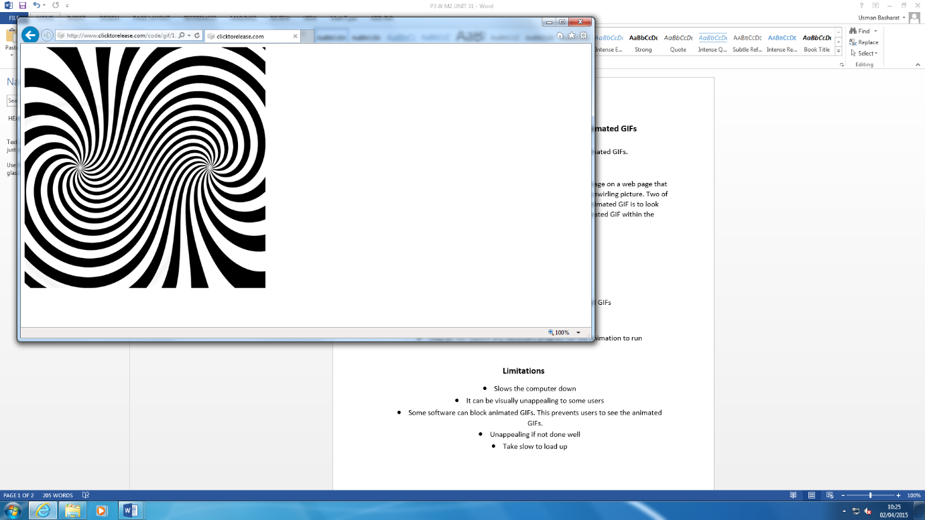**Introduction**

In this report, I will discuss the advantages and disadvantages of animated GIFs. I will also explain and compare the different animation formats.

**Animated GIF**

GIF stands for graphics interchange format. An animated GIF is an image on a web page that moves. They are different types of animated GIFs too. As you can see, it is an example of an animated GIF. This is a swirling picture. Two of the points, shown on the picture, are swirling. The main aim of the animated GIF is to look attractive. If not attractive, there will be not point of putting an animated GIF within the web page.

**Advantages**

* Small file size
* Only a few web browsers support animated GIFs
* Easy to use
* Easy to make
* They do not require any necessary program for the animation to run

**Limitations**

* Slows the computer down
* It can be visually unappealing to some users
* Some software can block animated GIFs. This prevents users to see the animated GIFs.
* Unappealing if not done well
* Take slow to load up

**Dynamic HTML**

Dynamic HTML (DHTML) is a different type of HTML. It uses animation and makes it more animated with a combination of Hypertext Mark-up Language tags. A classic example of a dynamic HTML is that the colour of the text changes when the user uses the mouse to drag it to another web page. Also, another addition is that the user interacts with the animation. A simple example is shown below.

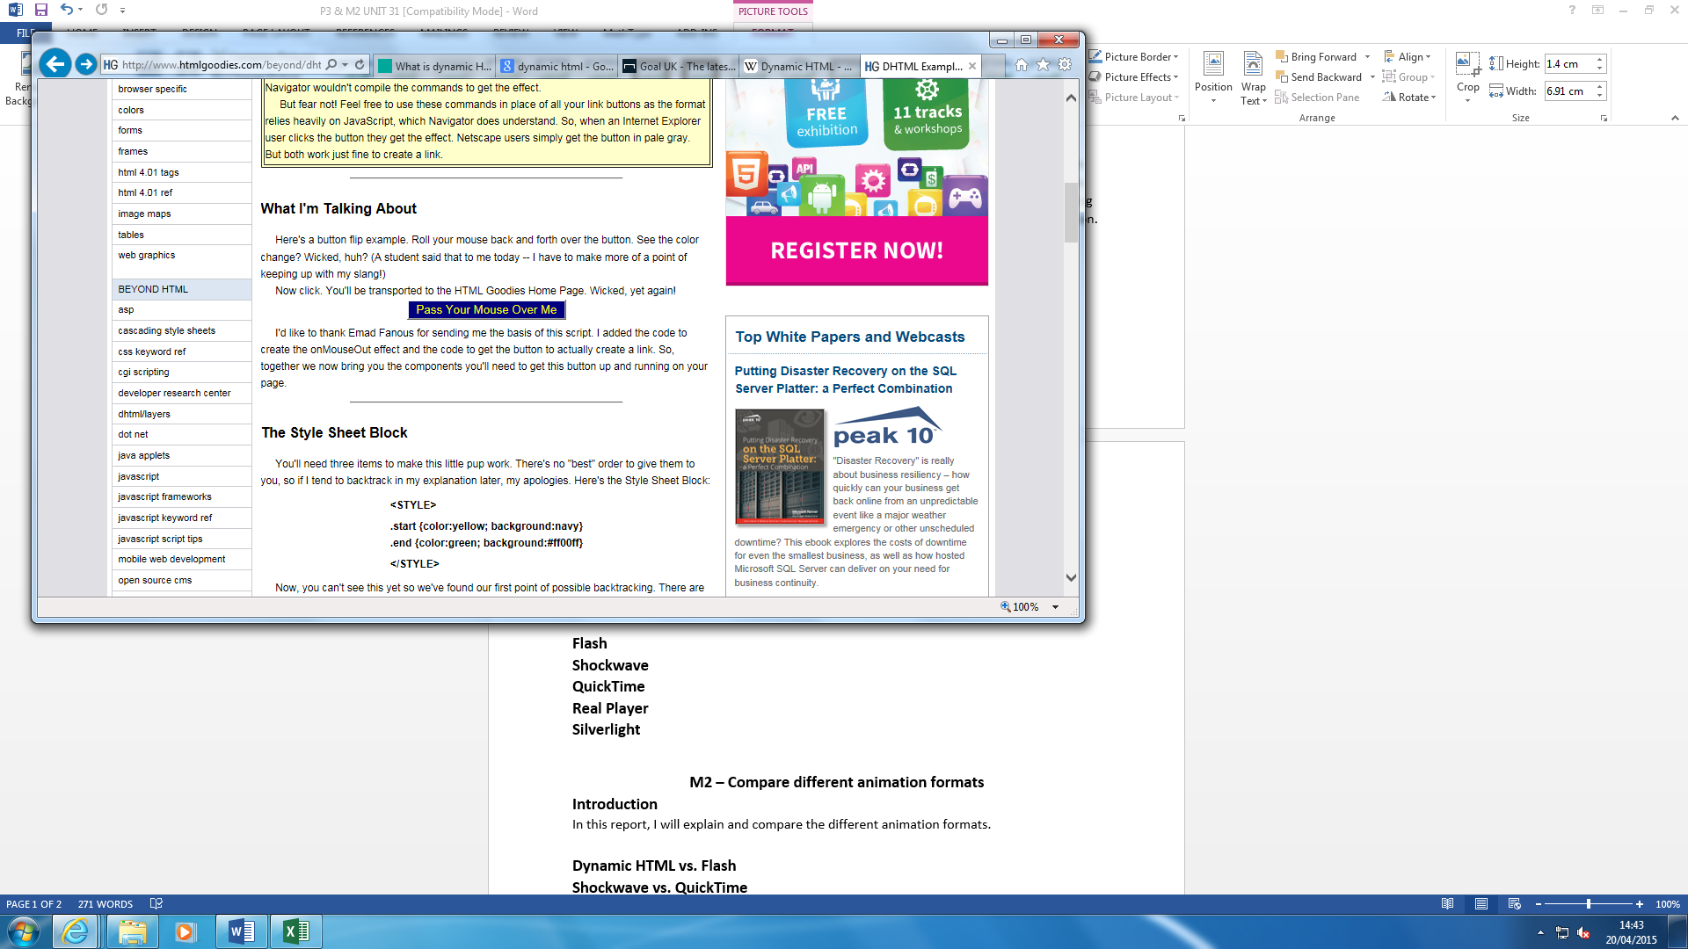

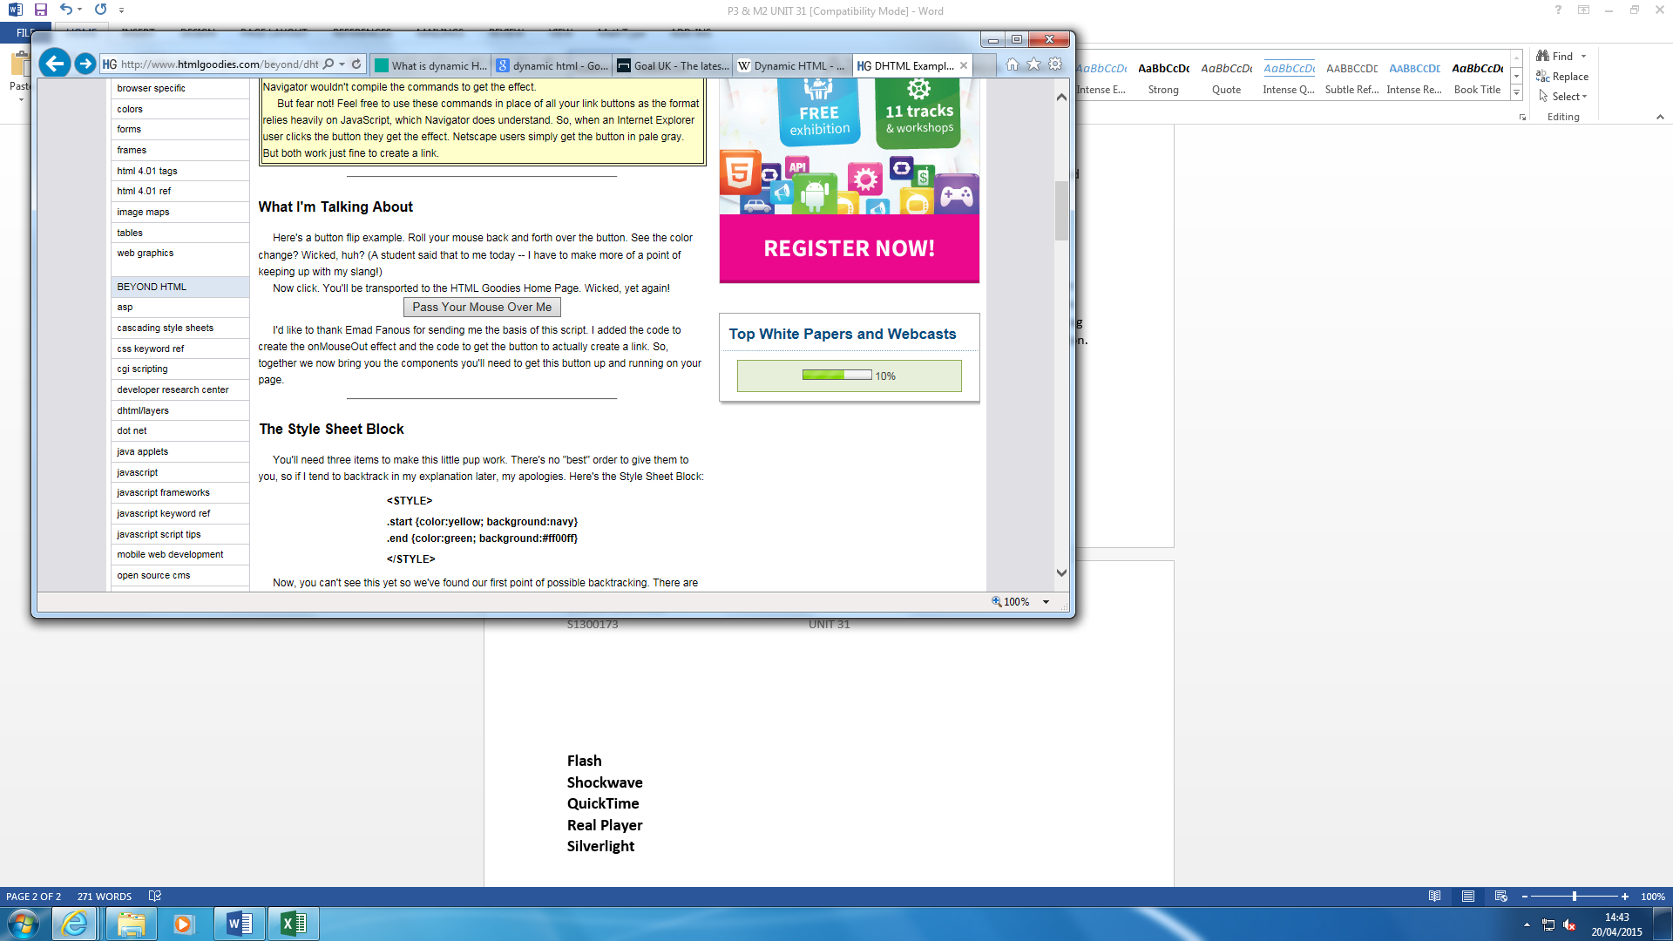

**Advantages**

* Fast
* Plug-ins is not needed. Plug-ins are features that is used within animations that supports the animation that is going to happen. With that being said, it is not needed.
* The utility of animation is helping the user create web pages. It is efficient and easy once it is complete.

**Disadvantages**

* Very long to code the animation
* Some browsers do not accept DHTML
* Costly tools – Adobe Photoshop and come at a cost and it is very expensive to purchase.

**Flash**

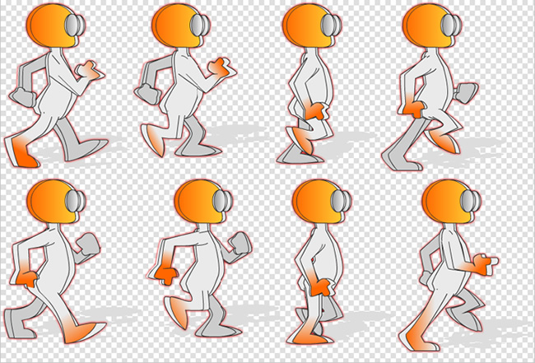Flash is used in Adobe Flash by creating similar animations. It could be known as Flash cartoon too. This tells us that it is used with cartoon series too; but it is not only used for cartoon, but web too. The picture below shows us the steps of an animation used within Adobe Flash.

**Advantages**

* Gives the users a different insight to what the message is trying to get across
* Easy to understand for non-speaking language customers
* Used for promotion
* More appealing to customers

**Disadvantages**

* Flash file would not work on mobile devices
* Websites with heavy use of animation tends to take very long to load
* Long process for the animation to update
* Once the animation is put in, it stays

**Shockwave**

Adobe Shockwave is a software that is used for various types of animation. It was initially used for videos and movies; however, it is now used for games too. It allows 3D animation to be used. Shockwave is used for Windows and Mac.

**Advantages**

* It not only supports animations; but video, movie and games too
* You can create your own on the software to add to any website too
* Fast once the shockwave is up and running

**Disadvantage**

* It lacks support for other operating systems such as Linux and Solaris
* Shockwave is a requirement for the animation to work. If not installed, the animation will not work

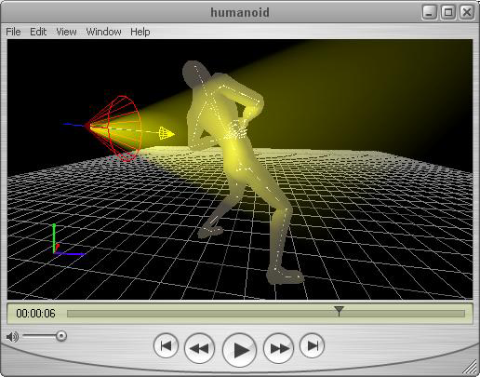

**QuickTime**

QuickTime is developed by Apple, but it is capable to be used on Windows and Mac too. It is capable of handling videos. QuickTime Pro is used to create movies. The picture on the right shows how QuickTime is used. It can use some of the softwares shown above.

**Advantages**

* Deals with large files
* It will enable and stream the whole movie

**Disadvantages**

* Quality is at a limit
* The bandwidth for QuickTime is not good enough. For instance, if 1080p is used, it will be reduced to 720p or 480p.

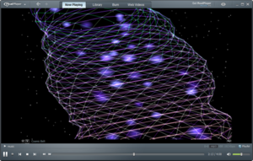**Real Player**

The job for Real Player is similar to Quick Time. A multimedia player can support QuickTime and Windows Media format and many others. It also can be used on other operating systems such as Linux, Unix and others.

**Advantages**

* Available on many operating systems
* Supports many file format for medias
* Free to download

**Disadvantages**

* Very old
* Takes long to load
* If the user does not have an internet connection, it would be slow.

**Silverlight**

Silverlight is an application that has similar attributes to Flash software. The difference between the two is that it is time-based. This means that it has ‘start’ to an ‘end’.

**Advantages**

* Silverlight offers support for applications
* Plug-in is used, which only Windows supports

**Disadvantages**

* Silverlight requires plug-in, but some users will not use extra storage for plug-in not enabling them to use the animation on the web page.

**Comparison**

**Dynamic HTML vs. Flash**

The main difference between the two is how it is created. DHTML is used by using HTML, CSS and JavaScript by inserting it on an appealing website. However, Flash does the same thing, but does the content in video, image and text format. It is going to be the same the way the user views the whole animation, once it is done; but the make of it is different. When you are creating DHTML, you do not need anything. All you need is to code the whole piece. Even this, you can download the free software through the internet. However, for Flash, you need the specialised software to create it as the software is sold by Adobe.

**Shockwave vs. Flash**

Shockwave is mainly used for games, but Flash is mainly used for online. However, both do vice versa jobs too. Flash is used for YouTube too. YouTube is a popular site for the use of watching videos. Instead of Shockwave, Flash has been used. In terms of availability, Flash has more plugins than Shockwave. Shockwave can be only used on Windows and Mac.

**Real Player vs. QuickTime**

They are both similar in age. Real Player was released 20 years ago, and QuickTime was released 23 years ago. They both can support Windows and Mac operating system with any other system. The difference is that they both can be released on different languages. This makes it unique and different to QuickTime, because it has been updated. However, in terms of cost, they are both free and can be downloaded on the website. In terms of job, they both do the same thing.

